### **How can I send emails using Google Mailer and integrate it into my local project?**

Follow these steps to send emails using Google Mailer and integrate it into your local project

### **Step 1: Install the WP Mail SMTP Plugin**

1. Go to your WordPress **Dashboard** > **Plugins** > **Add New**.
2. Search for "**WP Mail SMTP**".
3. Click Install Now, then **Activate**.

### 

### **Step 2: Configure WP Mail SMTP Plugin**

1. Go to **WP Mail SMTP > Settings** in your WordPress dashboard
2. Under **Mailer**, select **"Google / Gmail"**.
3. Fill in the following:

* **From Email**: your Gmail address (e.g., youremail@gmail.com)
* **From Name**: your name or website name
* **Return Path**: Check this box to match the From Email  
  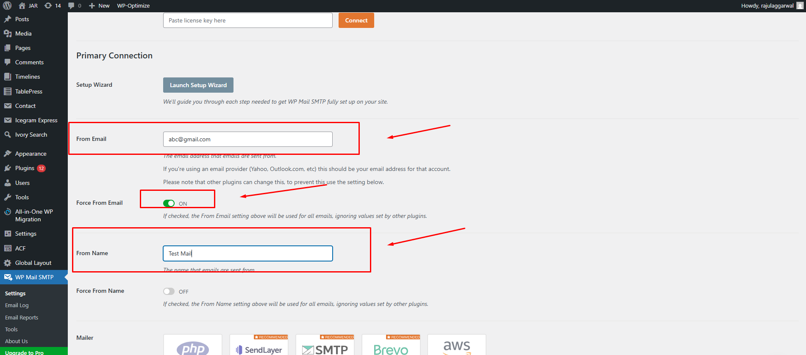

### 

### **Step 3: Set Up Google API (OAuth for Gmail)**

1. Visit [Google Cloud Console.](https://console.cloud.google.com/)
2. Click on **"Select a project"** > **New Project**.  
   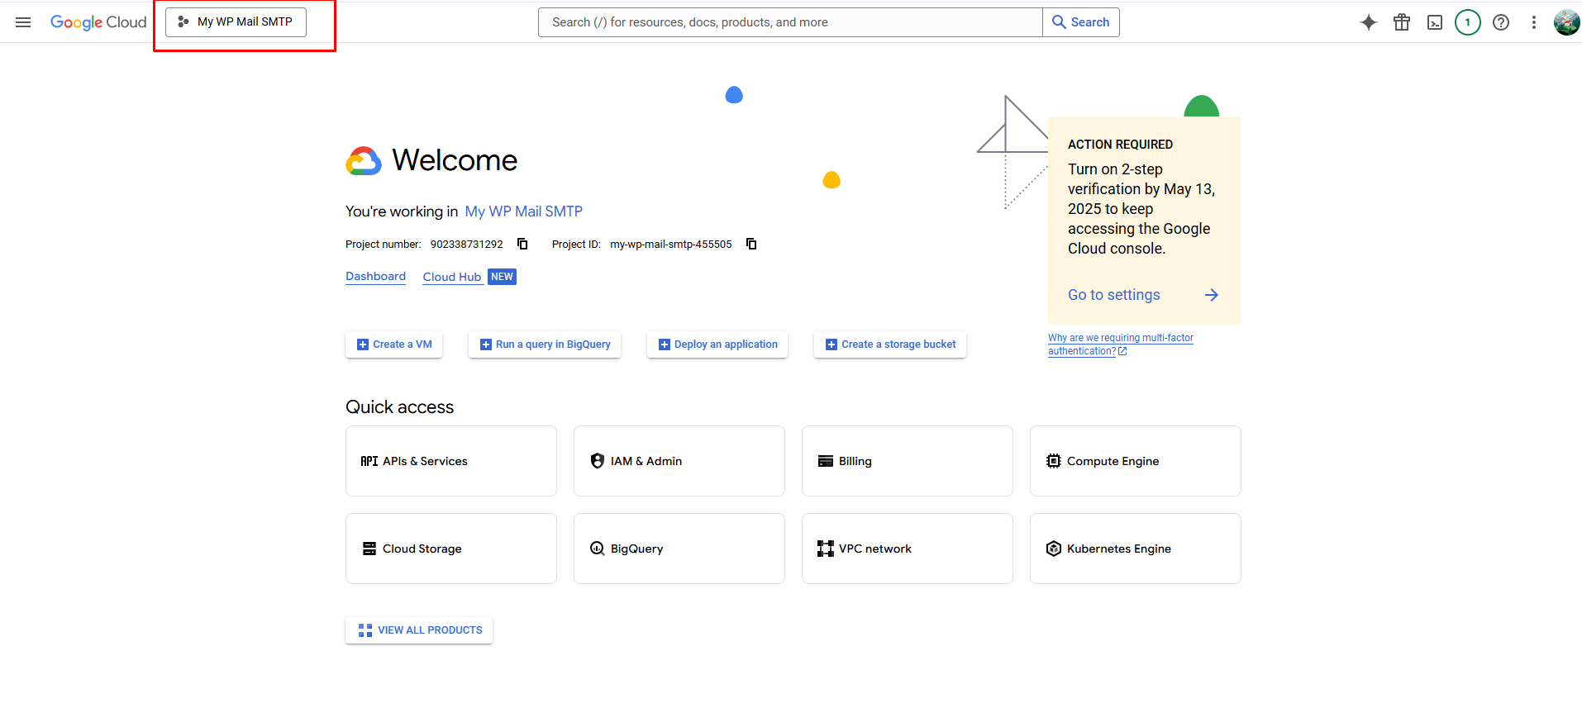

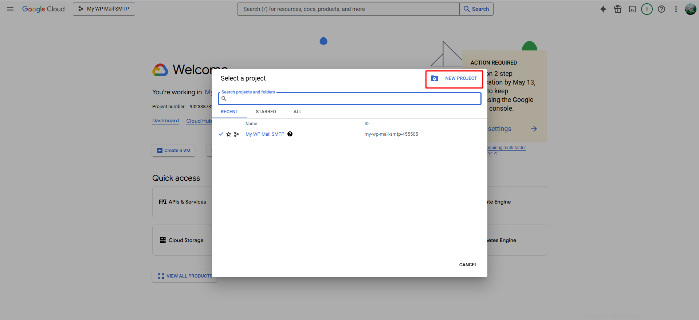

1. Enter a name (e.g., WP Mail SMTP) and create the project.

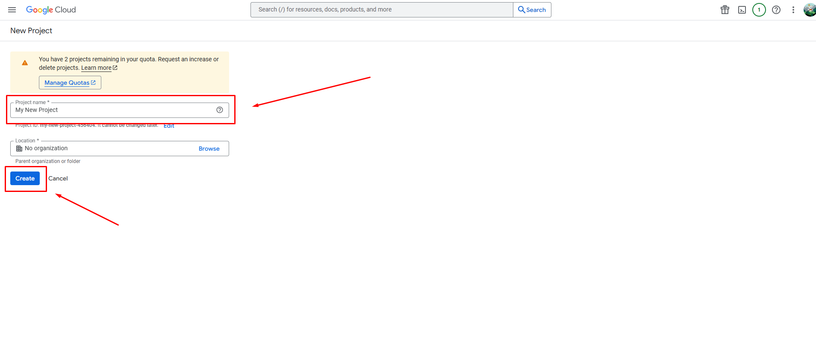

4. Select the newly created project.  
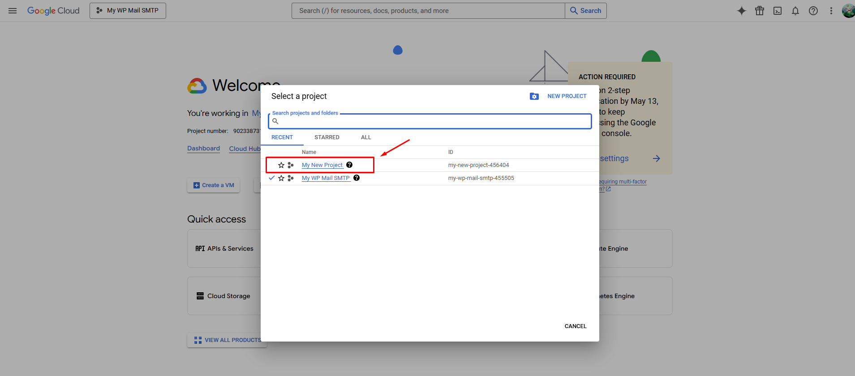

#### **🚀 Enable Gmail API**

1. In the left menu, go to **APIs & Services** > **Library**. 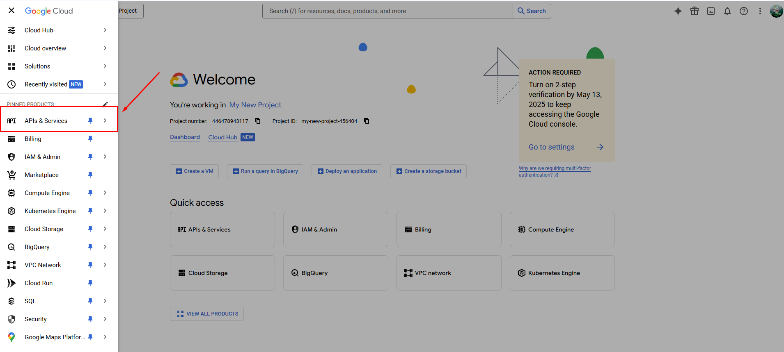
2. Now, click **on enable API and services  
   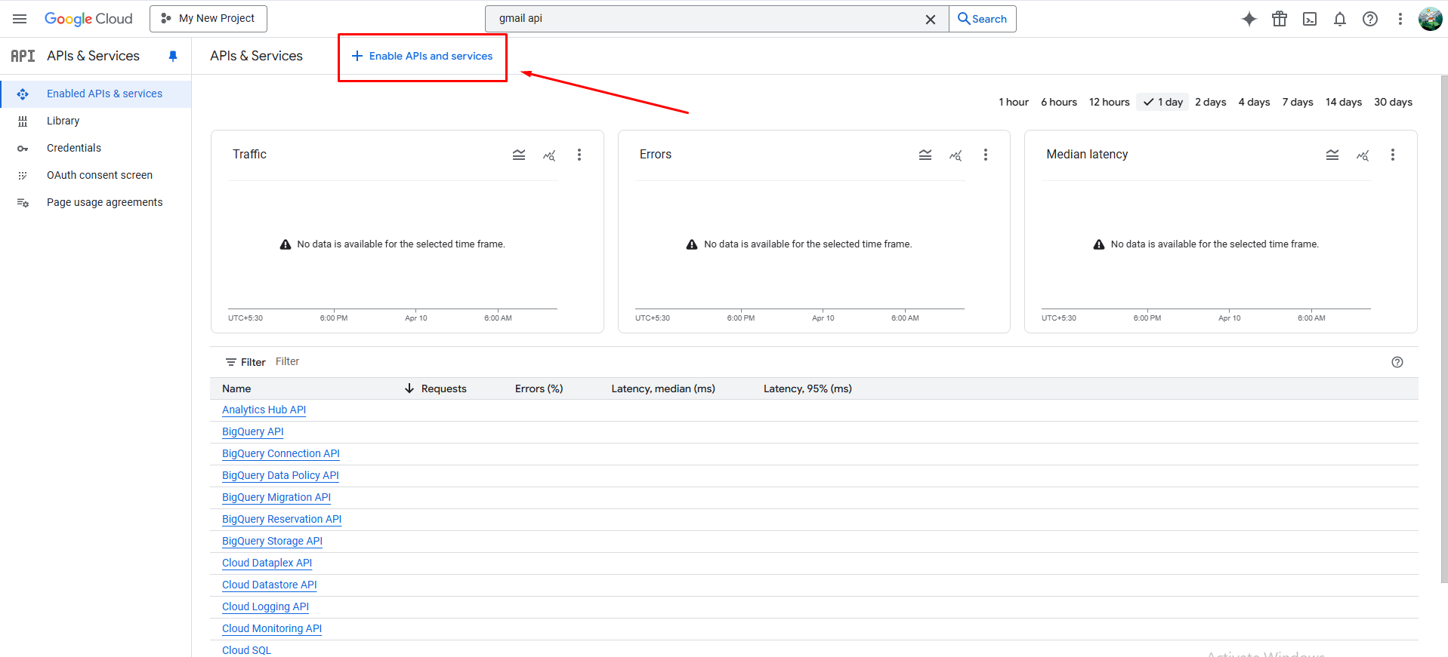**
3. **Now search for Gmail API and click on it  
   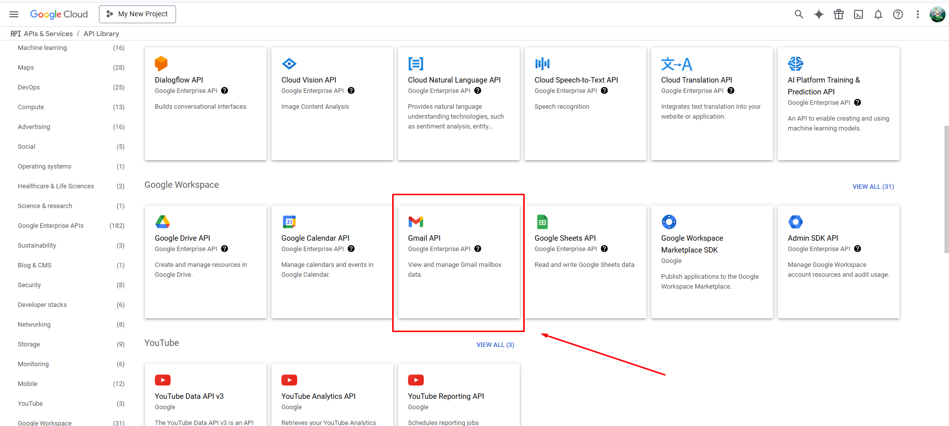**
4. Click on **Enable  
   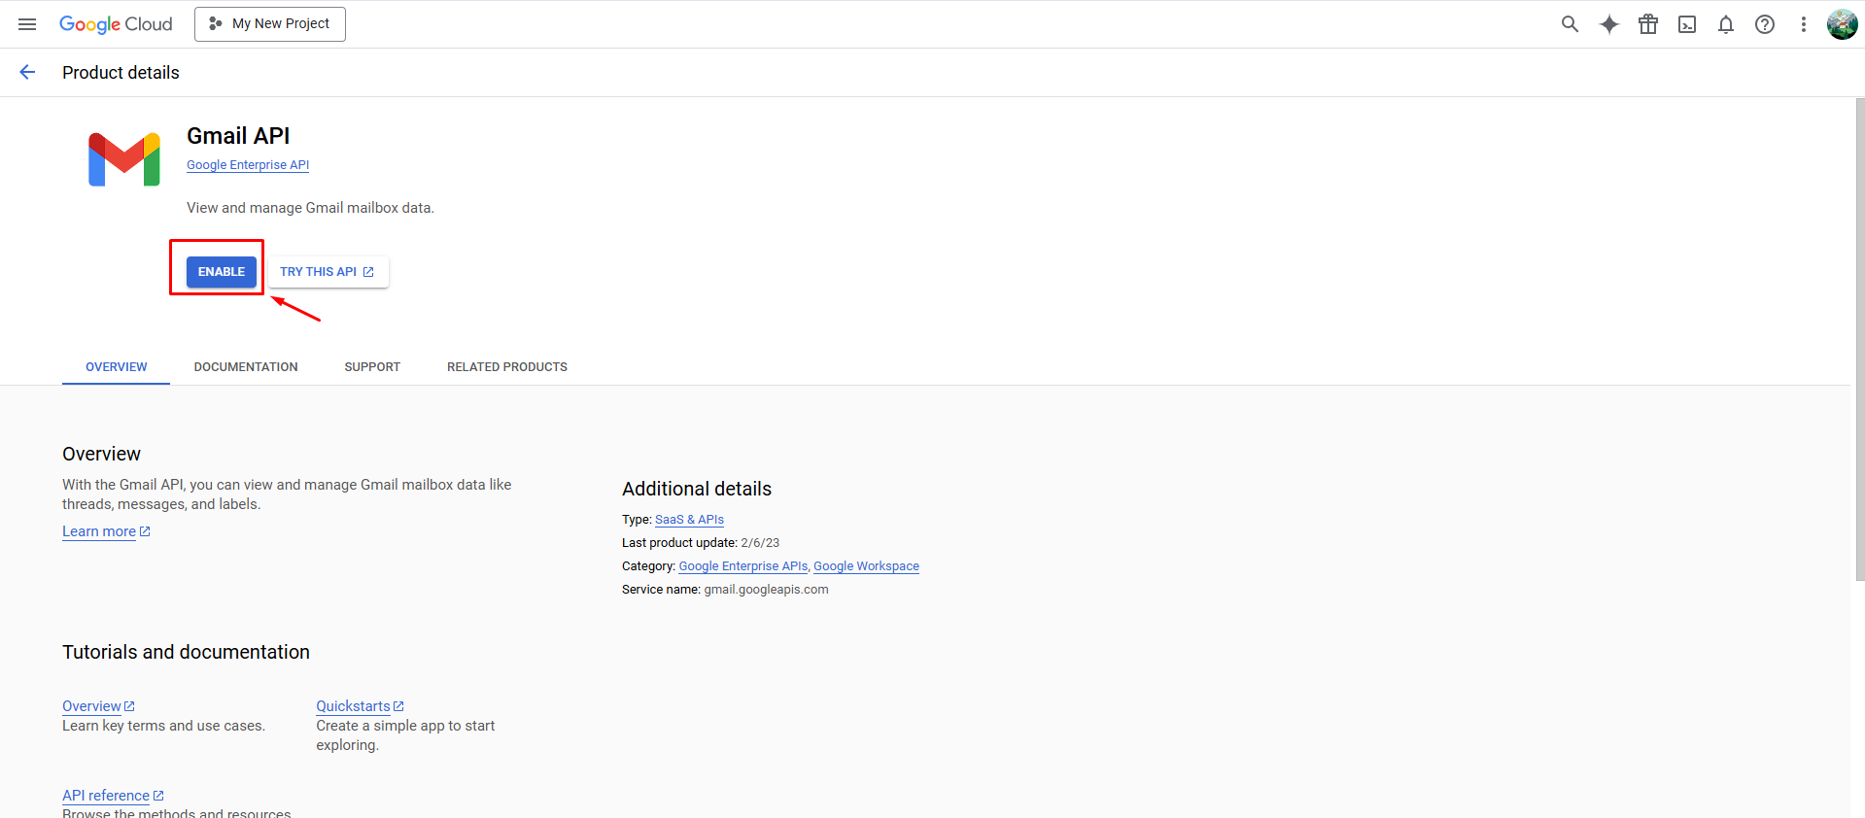**

#### **🔐 Set Up OAuth Consent Screen**

1. Go to the **OAuth consent screen** from the left panel.  
   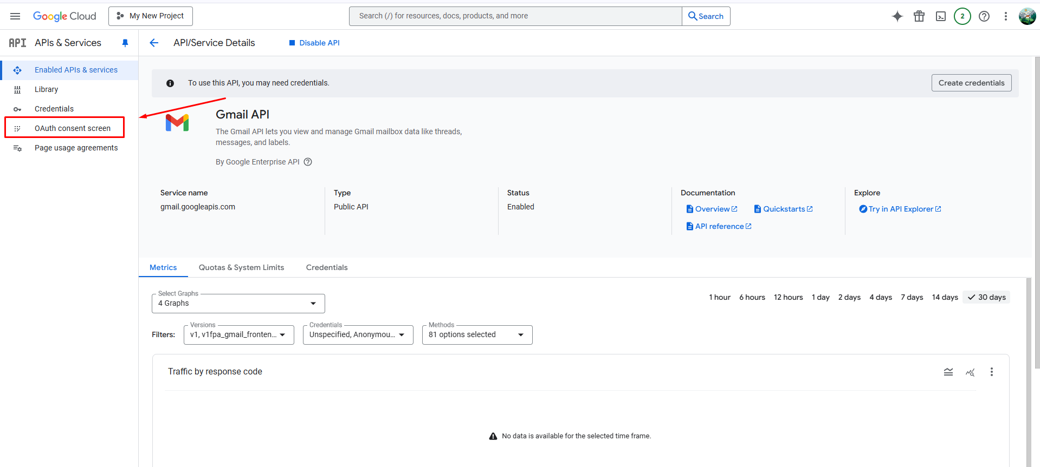
2. Fill in all the details here and click on **Create**   
   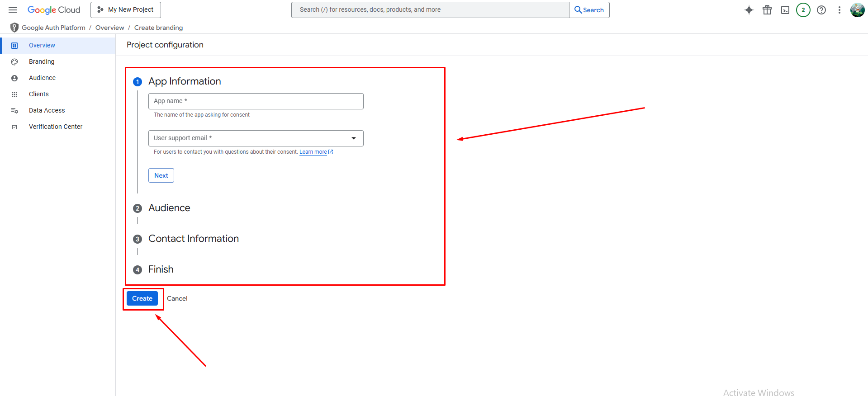
3. Fill in:  
   * App Name -> abc
   * User Support Email -> [youremail@gmail.com](mailto:abc@gmail.com)
   * Audience -> external
   * Contact Info -> [youremail@gmail.com](mailto:abc@gmail.com)

#### **🧩 Create OAuth Credentials**

1. Click on **Create OAuth Client**.  
   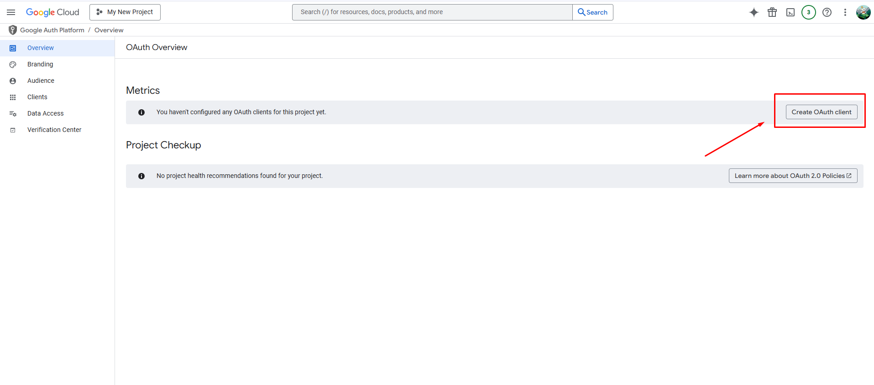
2. After that, choose **Web Application** in **Application type**.  
   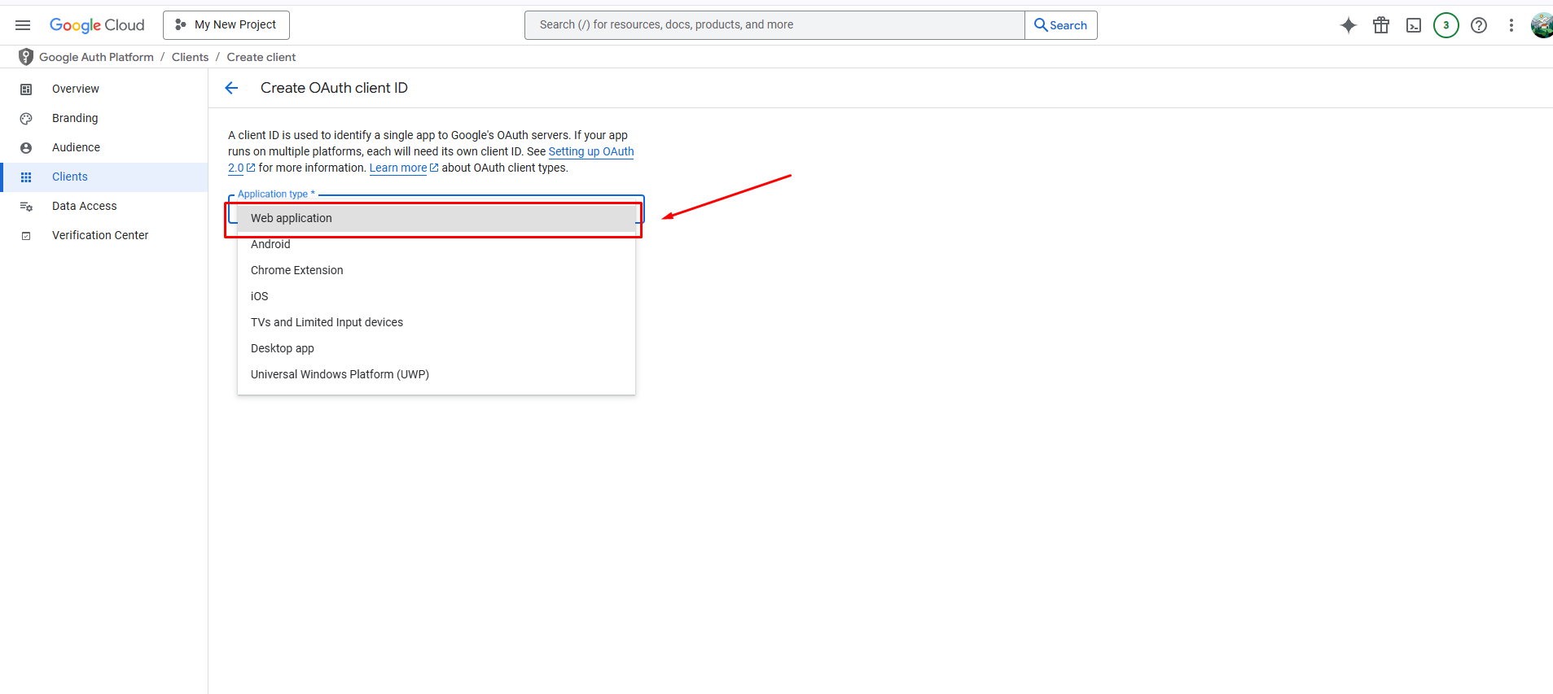
3. Add your Authorized Redirect URI as <https://connect.wpmailsmtp.com/google/> 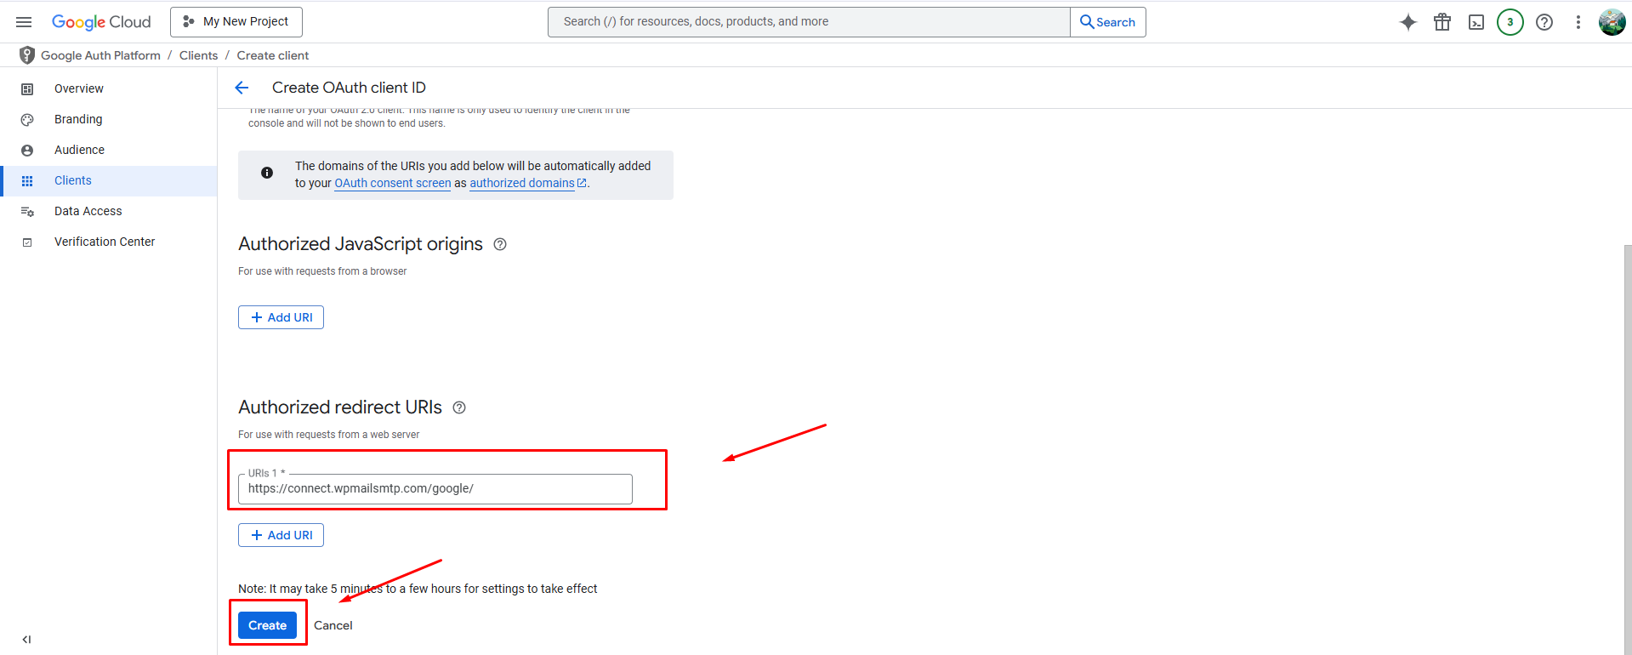.
4. Click **Create** and **copy** your

* Client ID
* Client Secret

5. Now, publish your app by clicking on **Audience > Publish app** from the left panel.  
 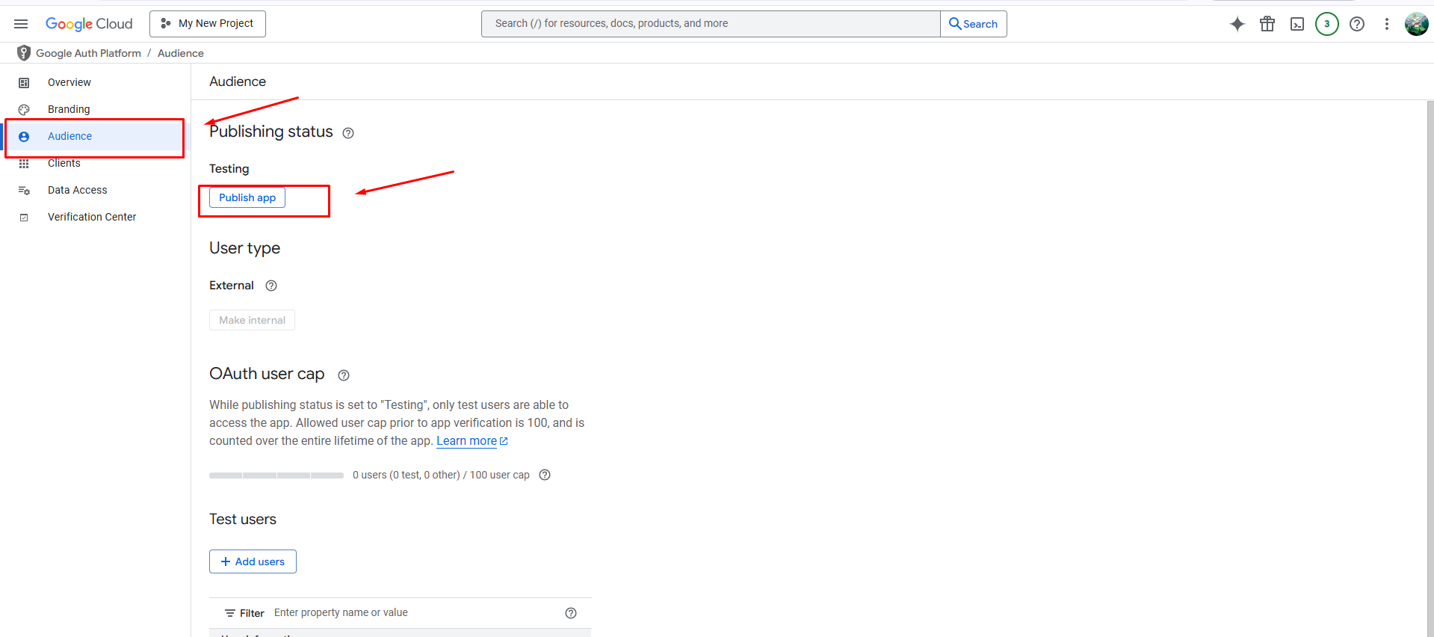

### **Step 4: Connect Gmail to WP Mail SMTP**

1. Go back to your WordPress dashboard:  
   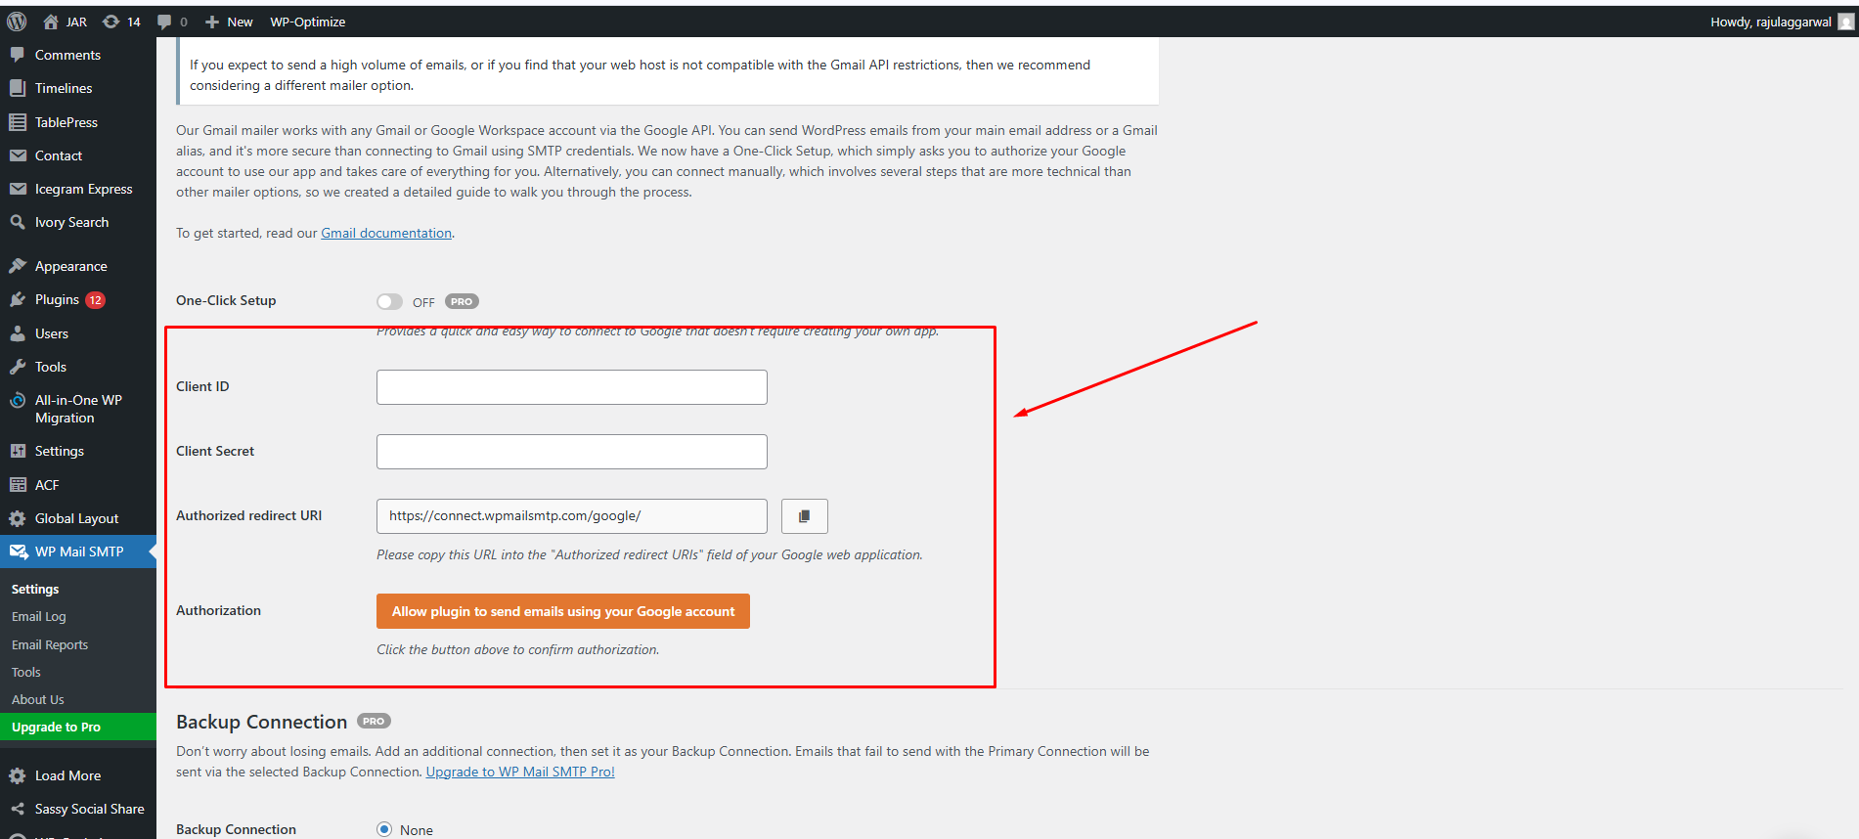
2. **WP Mail SMTP > Settings > Gmail**
   1. Paste the **Client ID** and **Client Secret**.
   2. Save the settings.
   3. Click the **Allow plugin to send emails using your Google account** button.  
      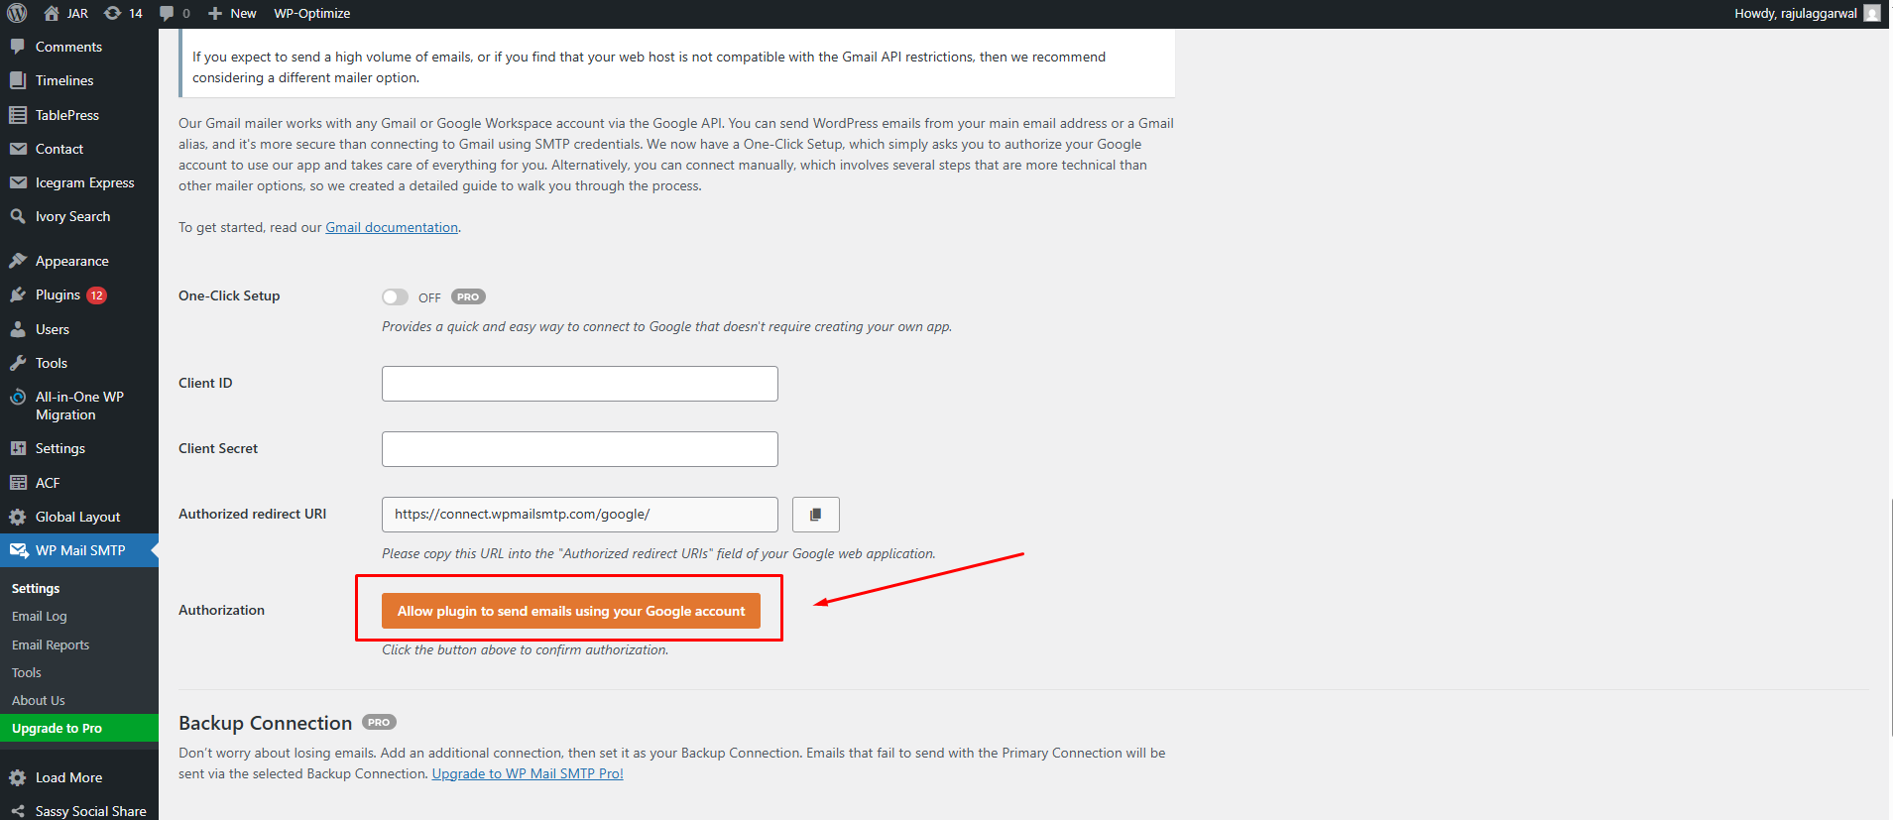
   4. Google will ask for permission—**allow** it.

### **Step 5: Send a Test Email**

1. Go to **WP Mail SMTP > Tools > Email Test**.
2. Enter an email address to send a test mail.
3. Click **Send Email**.  
   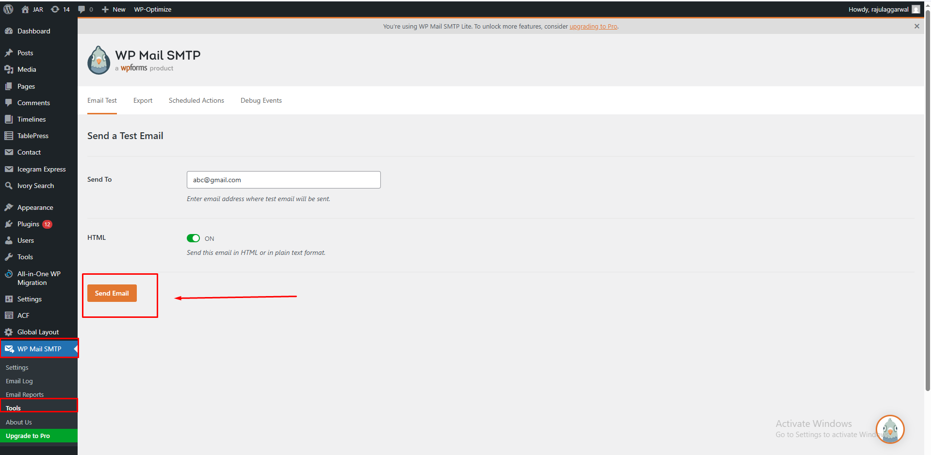

You should see a **success message**, and the email should be delivered!